ALICE WALKER
author, poet, and advocate

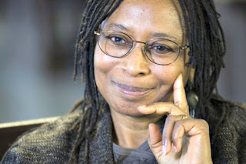
This Photo by Unknown Author is licensed under CC BY-SA
Learn more about her contributions:
